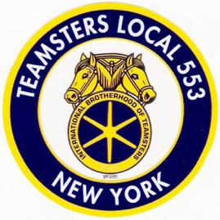
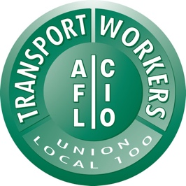
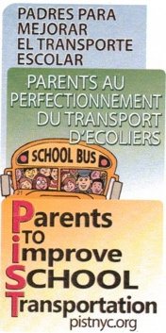
FOR IMMEDIATE RELEASE
April 27, 2020

Contact: Halimah Elmariah | helmariah@kivvit.com | 201-290-9753

COALITION OF SCHOOL BUS DRIVERS, UNIONS, SCHOOL BUS COMPANIES AND PARENTS RAISE A RED FLAG: SHUTTING DOWN NEW YORK CITY SCHOOL BUS COMPANIES IS A RECIPE FOR DISASTER

A Shut Down Means School Transportation Won’t be Ready for Kids When School Resumes

School Bus Drivers Are Ready, Willing and Able to Help in Other Ways Like Transporting Student Meals and Creating Portable WiFi

New York, NY – A coalition of school bus drivers, unions, school bus companies and parents are raising a red flag – saying that if New York City school bus companies are shut down, it would cause a disaster when schools reopen.

On a regular school day, 10,000 school buses travel across the five boroughs to safely transport 150,000 students to and from school. Parents and students rely on this essential service to start and end each school day. The reliability, safety and peace of mind the industry presents should not be taken for granted. For the city’s most vulnerable population, special needs children, it is essential that bus drivers remain consistent for their well-being.

If the school bus yards are shut down, it would cause havoc for drivers and their families and it would put any school start date in jeopardy. Some of the effects would be:
- 16,000 workers laid off immediately;
- Workers and their families would lose their health insurance – during a global pandemic;
- Drivers and attendants would lose their state and local certifications – making it nearly impossible to return to work when school starts;
- Buses could not be maintained, once again making it nearly impossible to return to normal when school starts.

In the meantime, the dedicated school bus workers are ready, willing and able to assist New York City in the fight against COVID-19 by:
- Delivering meals to children in need
- Turning buses into Wi-Fi hotspots for students to access online learning
- Picking up course work and dropping it off at students’ homes
- Transporting nurses, military personnel, and other essential workers so they can avoid riding public transportation and adhere to social distancing guidelines
- Delivering PPE supplies wherever needed

The coalition includes: ATU Local 1181, TWU Local 100, Teamsters Local 533, Parents to Improve School Transportation (PIST), and NYC school bus providers.

Many school buses will be due for inspection when school resumes. New York State DOT inspectors typically review 100 vehicles a day systemwide. If ten thousand school buses have invalid DOT stickers by the time schools return to normal, this process alone could take months.

In addition, with the reopening of schools, it will take additional time and resources to ensure that bus drivers are equipped with necessary personal protection equipment, receive updated safety training to prevent the spread of the virus, and get tested themselves.

The decision to shut down school bus companies will disrupt the education of thousands of children across New York City, more than it already has been. Schools are already handling one crisis – let’s not create another.

###

